DON’T BE THE DEALER…
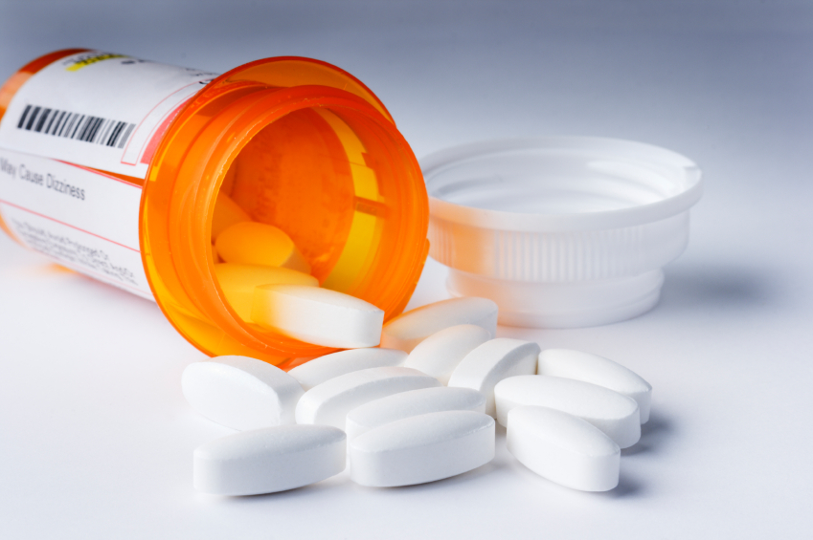

• Keep them safe.
• Clean them out.
• Take them back.
Saturday- April 24th, 2021
9:00 a.m.-12:00 p.m.
Riverview Health Noblesville- East Parking Lot
Drop off expired or unused medications. Vape devices can also be dropped off.
No Liquids, Sharps or Needles Accepted!
COVID-19 protocols will be followed. The format is a drive-thru drop off, a police officer wearing PPE will obtain the donations from the driver.
Sponsored by:
Hamilton County Council on Alcohol and Other Drugs
Hamilton County Health Department
Breathe Easy Hamilton County
National DEA RX Take Back Day

