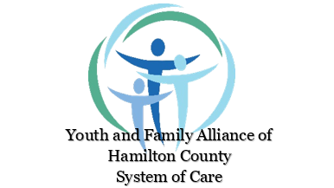

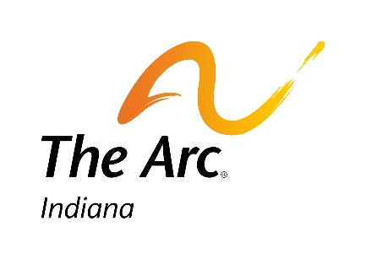
Making your insurance work for you - from the Hamilton County Youth and Family Alliance and The Arc of Indiana Insurance Advocacy

Virtual Dine & Discuss

Optimizing health means the right diagnosis and the right care in the right setting. But insurance can be so confusing!
For all Caregivers - understand what is involved in private insurance and Medicaid, what your youth can be eligible for, and how to advocate for the best use of your insurance.
There will be time for Q&A as well!
Register here > https://www.eventbrite.com/e/insurance-and-mental-health-services-what-caregivers-need-to-know-tickets-153382905399

