Opiates In Our Society
What Will You Lean:
The effects of opiates on the body.
Stigma and substance use.
Signs and symptoms of opiate use.
Three signs of an opiate overdose.
Recall various treatments.
Much more!

Location of the course: Hamilton County Juvenile Probation & Shelter
Care Annex

Date of course: June 30, 2021

Time of the course: 1:00 p.m.-2:30 p.m.
Cost of the course: FREE
How to register for the course: https://www.eventbrite.com/e/opiates-in-our-society-tickets-156767205933

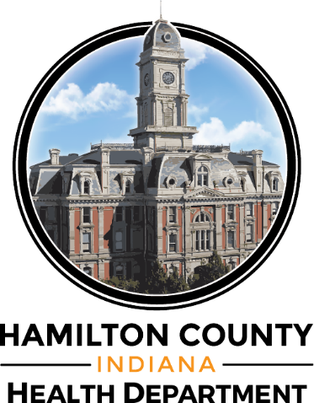
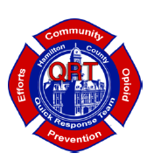
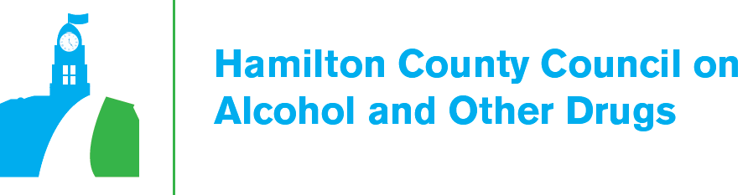
This course is sponsored by:

